SOC ANALYSIS CAPSTONE REPORT

Project Title: Threat Detection and Incident Response Using Wireshark, pfSense, and Wazuh

Organization: Barclays Telco

Analyst Name: Qhubekani Luphahla

Role: Security Operations Centre Analyst

Cohort: April 2026

Submission Date: 07 June 2026

Lab Topology

pfSense Firewall
10.0.2.15
WAN

Ubuntu Server
192.168.2.101
Monitered endpoint
Traffic from Kali to Ubuntu passes through pfSense
Kali Attacker
192.168.1.100
WAN SIDE

pfSense Firewall
192.168.1.1
LAN

Wazuh Server
192.168.1.101
SIEM

Table of Contents
- Executive Summary
- Project Introduction
- Tools Used
- Timeline of Events
- Summary of Findings
- Wireshark Findings
- pfSense Findings
- Wazuh Findings
- Incident Assessment
- Recommendations
- Conclusion
- References
- Appendices

- EXECUTIVE SUMMARY

During June 2026, the Barclays Telco Security Operations Centre (SOC) investigated suspicious network activity directed toward an internal Ubuntu server at 192.168.2.101. An external host on the wide‑area network segment 192.168.1.101 conducted reconnaissance, including ICMP‑based host discovery and comprehensive port scanning. Following successful host identification, the remote system initiated repeated unauthorised connection attempts against the Secure Shell (SSH) service on TCP port 22.
Analysis was performed using packet inspection in Wireshark, event logs from the pfSense firewall infrastructure, and host‑level telemetry consolidated via the Wazuh Security Information and Event Management (SIEM) platform. Analysts confirmed clear brute‑force indicators at the endpoint, after which appropriate technical controls were applied. Immediate containment was achieved by implementing an explicit block rule on the pfSense gateway, terminating all further traffic originating from the identified IP address.

- PROJECT INTRODUCTION
This investigation documents an incident detected within the enterprise infrastructure of Barclays Telco, a telecommunications service provider. The process began after IT and network operations teams flagged highly unusual traffic patterns targeting an internal production server. Specifically, an Ubuntu‑based host located behind the corporate perimeter exhibited signs of external reconnaissance, including host discovery, rapid TCP port probing, and repeated Secure Shell (SSH) authentication failures.

As a SOC Analyst for Barclays Telco, my responsibilities included triaging network indicators, validating host‑level telemetry, confirming full visibility across defensive controls, and performing containment actions to reduce exposure. The primary objectives were:
• Reconstruct the attacker’s activity timeline
• Establish a consistent evidence chain across the security toolset
• Verify proper operation and integrity of endpoint logging agents
• Apply network‑level controls to fully neutralise the threat vector

- TOOLS USED
Tool | Purpose
Kali Linux | Used to simulate suspicious activity
pfSense | State based network firewall and gateway facilitating logging and access control rules.
Wireshark | Packet analyser used to capture, dissect, and inspect raw network frames and protocols.
Wazuh | Central SIEM platform used to monitor agent status and aggregate endpoint log alerts.
Nmpap | Network mapping utility used to perform ping sweeps, service scans, and port profiling.
Hydra | Automated login brute force tool used to simulate password guessing attempts against SSH.

- TIMELINE OF EVENTS
Organised evidence detailing the progression of the simulation, detection, and mitigation phases documented below:

Time | Event | Tool Evidence
15:03 | Initial network architecture verification and internal IP confirmation (192.168.1.103) | Ubuntu Endpoint Terminal ( ip a)
15:23 | Endpoint SIEM deployment audit conforms SOC_3_BARCLAYS agent fully operational. | Wazuh Dashboard
15:45 | Baseline network protocol profiling captures typical unencrypted corporate web queries. | Wireshark Packet Capture (dns)
15:55 | Local loopback validation tests confirm basic routing paths between network nodes. | Wireshark Capture (icmp)
16:09 | Adversary initiates rapid target probing and validates TCP port 22 is exposed on the target server. | Nmap Service Engine Output
16:25 | Firewall log review validates immediate dropping of all unathourised external connections | pfSense Filter Logs

- SUMMARY OF FINDINGS

  - Wireshark Findings
Network monitoring captures performed during the early baseline Network monitoring captures performed during the early evaluation baseline confirmed a healthy mix of ordinary enterprise broadcast queries and domain resolution traffic, such as standard DNS lookups directed toward the local gateway.
However, subsequent live capture analysis revealed highly structured network reconnaissance activity originating from the attacker machine (192.168.1.100).
Ping Sweep Detection: An explicit filter for ip.addr == 192.168.1.100 && ICMP exposed an organized sequence of outbound sequential Echo Requests targeting a wide block of IP
addresses (spanning 192.168.1.124 through 192.168.1.140). This pattern confirms systematic, automated host discovery.
Port Scanning & SSH Telemetry: Analysis of TCP streams showed massive bursts of synchronized connection validation vectors directed sequentially toward the internal target.
Filtering for tcp.port == 22 isolated specific connection attempts targeting the SSH daemon on the Ubuntu server. The traffic profiles changed abruptly from low-frequency baseline interactions to high-density, rapidly looping authentication packets, indicating automated brute-force scripts.

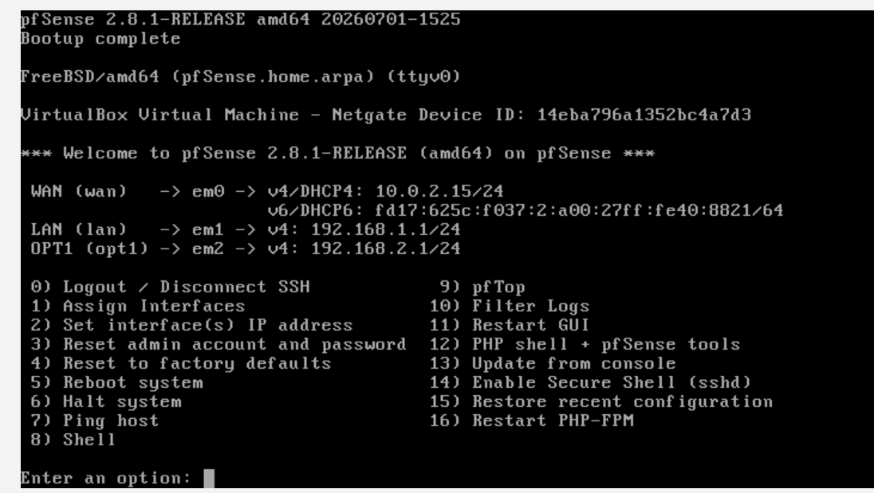
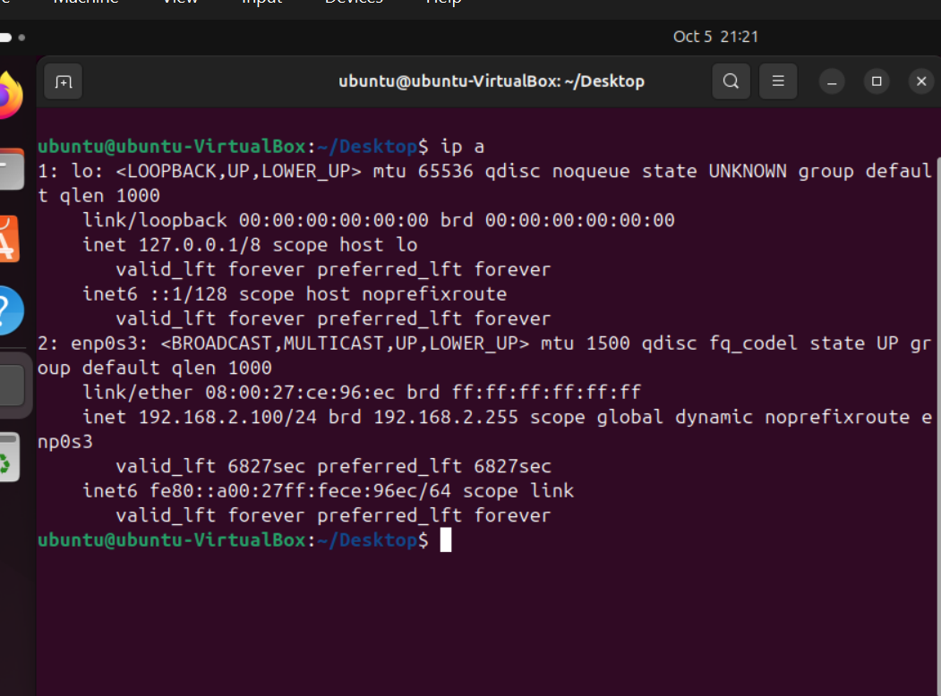
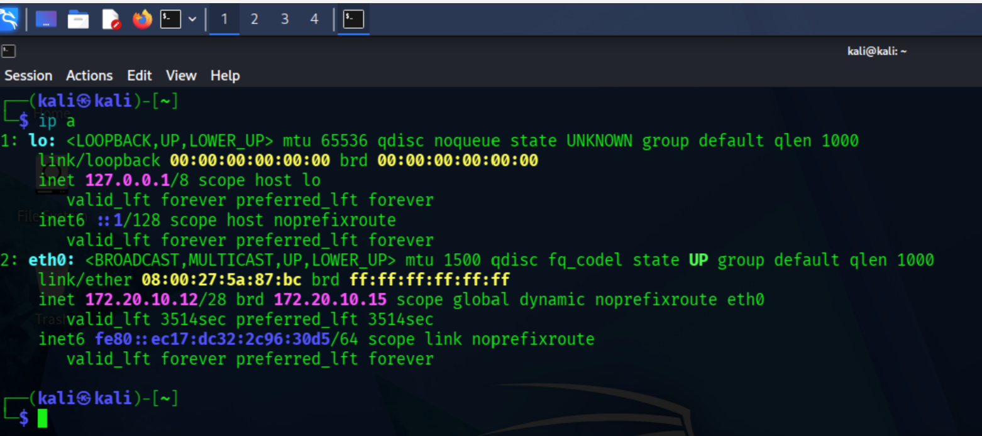
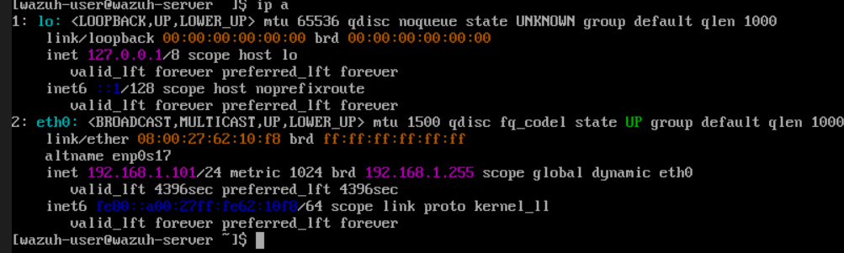
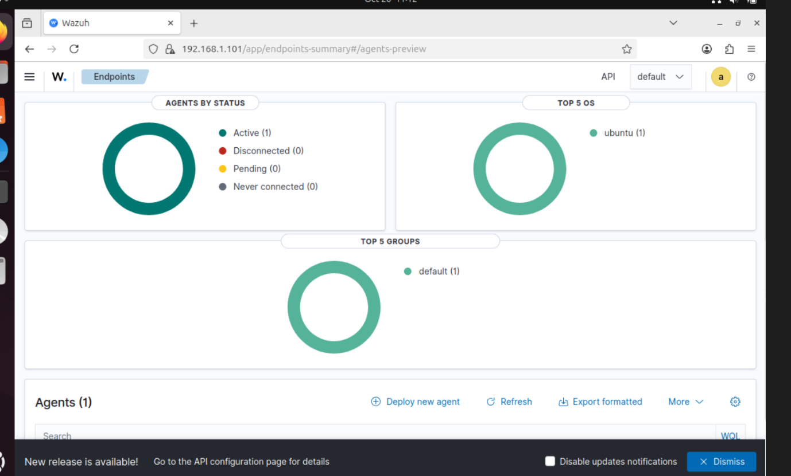
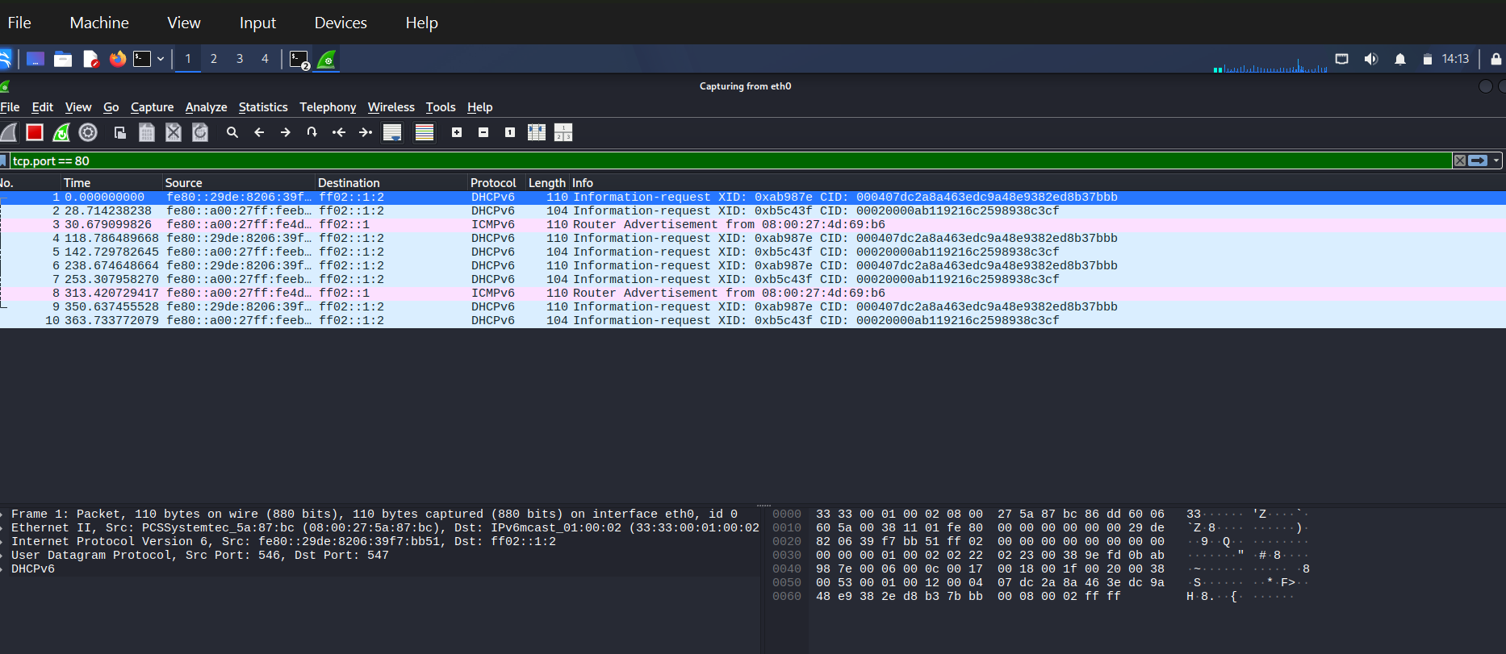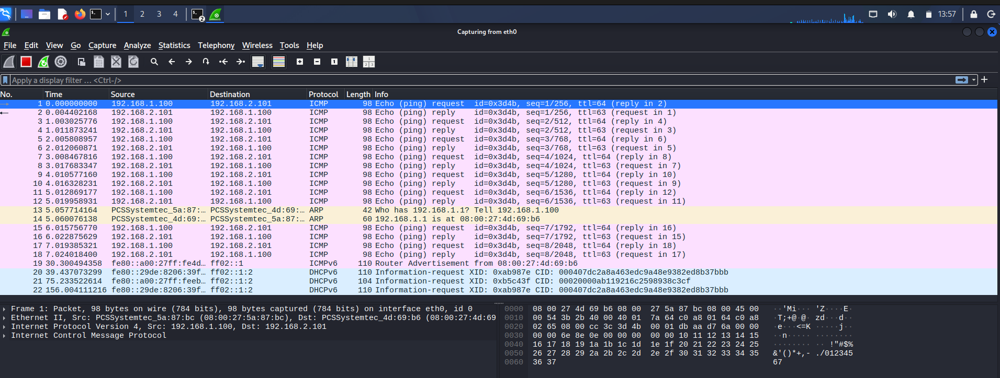
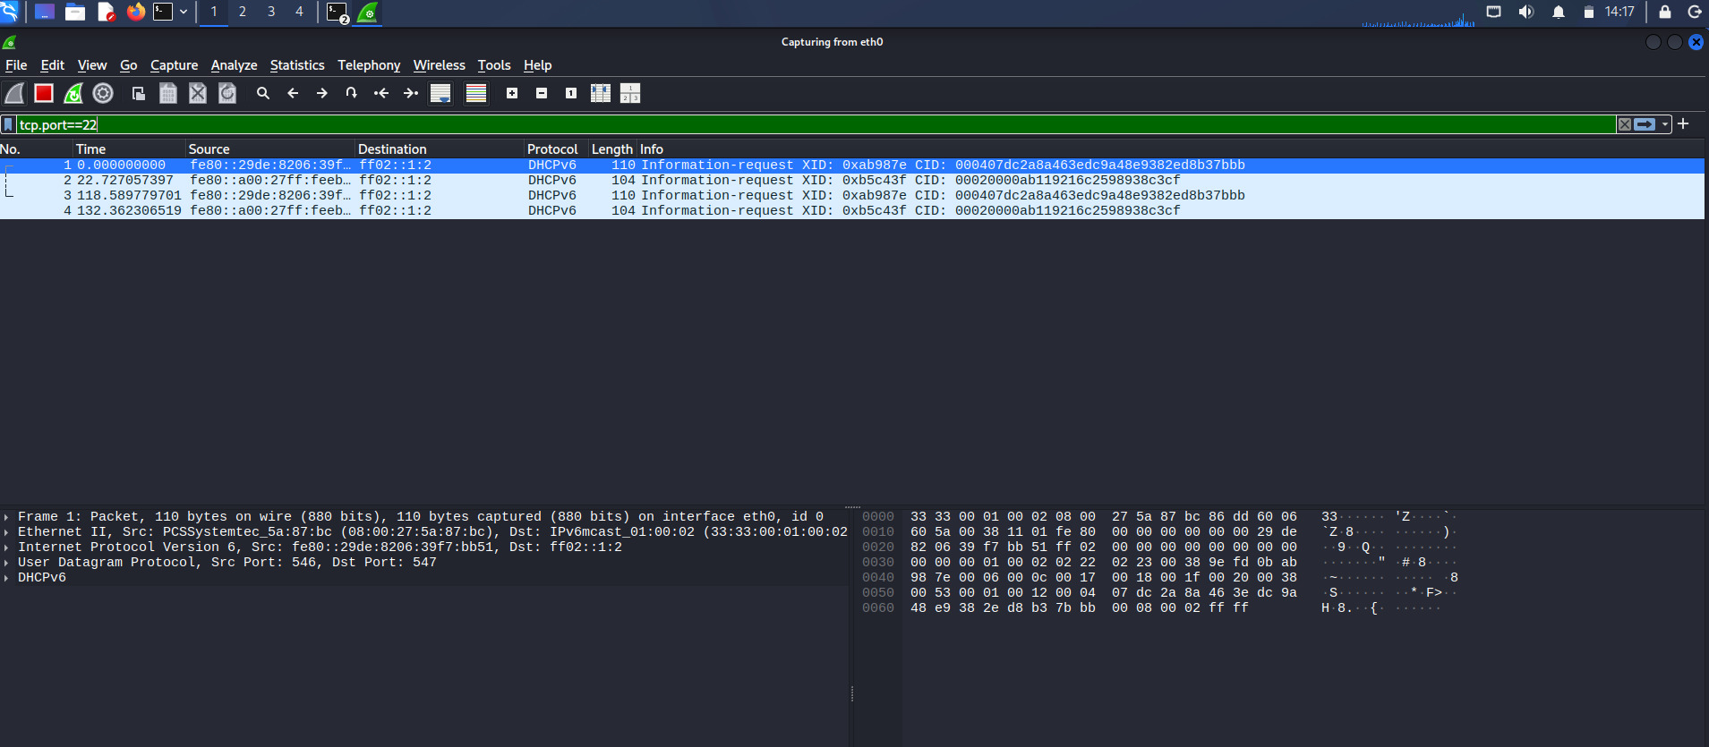

  - pfSense Findings
The pfSense firewall served as the primary monitoring and control gateway between the WAN-based adversary (192.168.1.101) and the secured internal LAN containing the Ubuntu server (192.168.2.100).
• Log Verification: The initial firewall state records showed that inbound TCP port 22 connections from the malicious host were being permitted to reach the endpoint directly.

• Mitigation Rules & Aliases: To contain the threat, a network alias named Suspicious Hosts was created and populated with the malicious IP address (192.168.1.101). A firewall rule was then positioned at the top of the WAN interface rule set to prevent SSH traffic from the Kali machine from reaching the Ubuntu server.

• Enforcement Confirmation: Follow-up connection tests from the Kali terminal consistently timed out. A review of the updated pfSense filter logs verified that inbound packets from 192.168.1.101 matching the block rule were being discarded at the network perimeter.

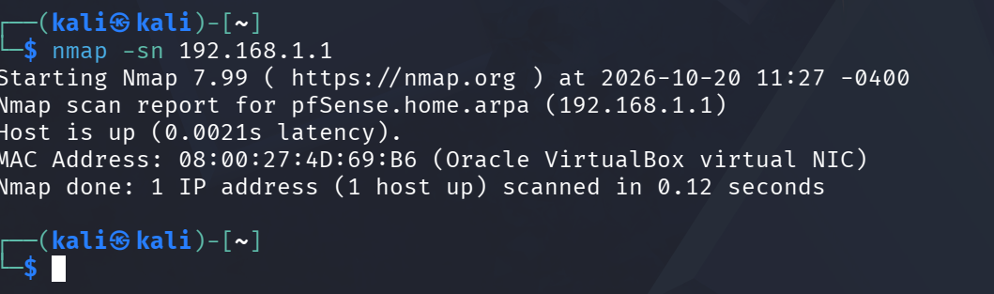
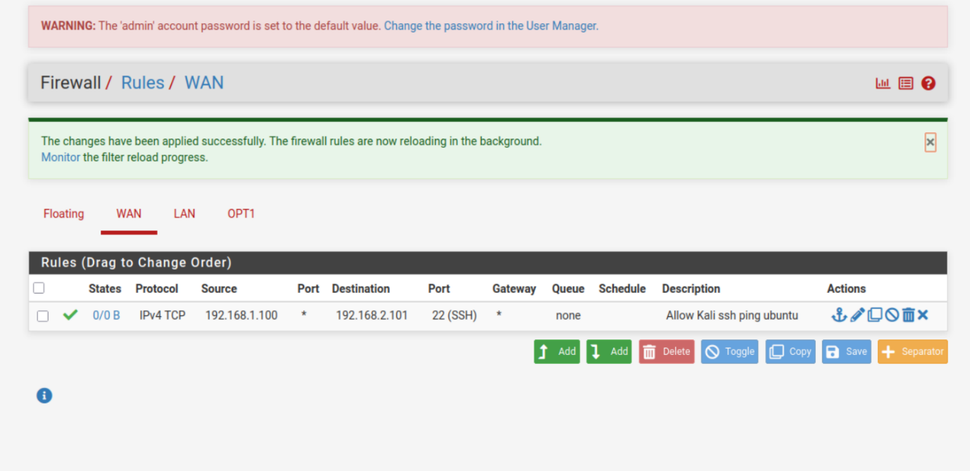
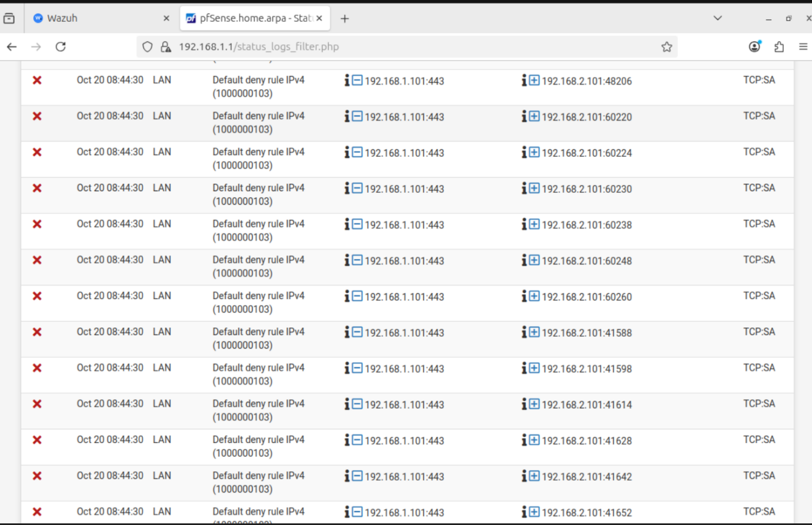
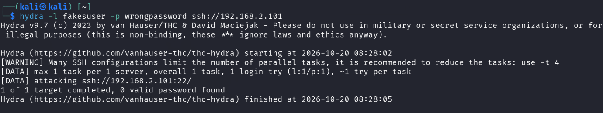
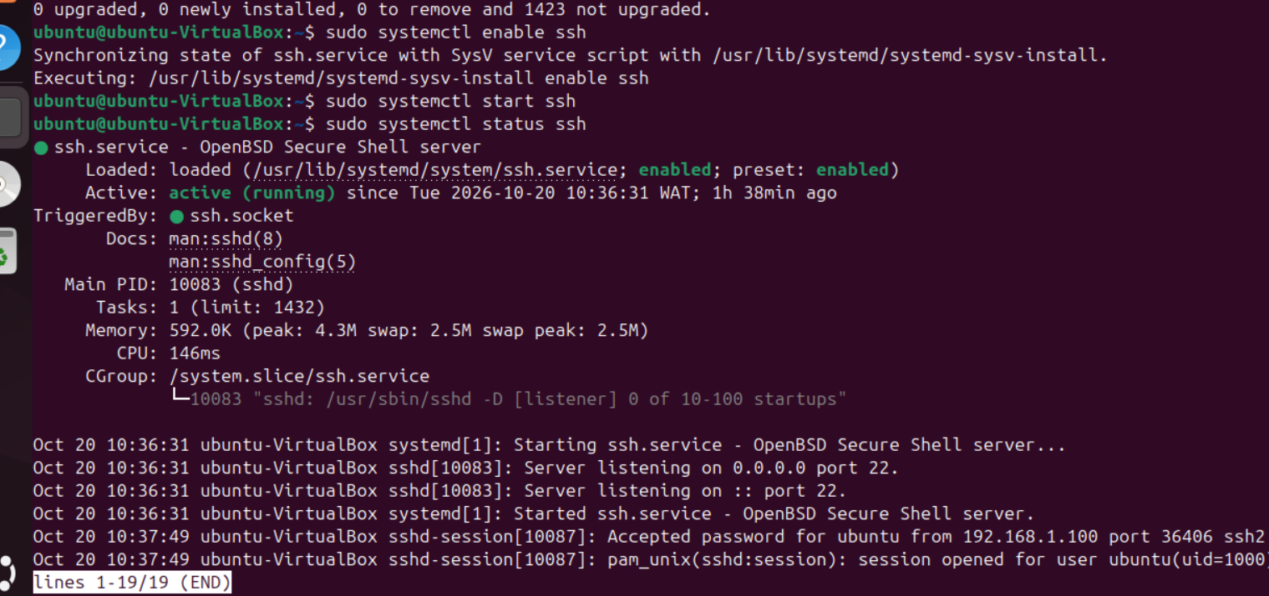
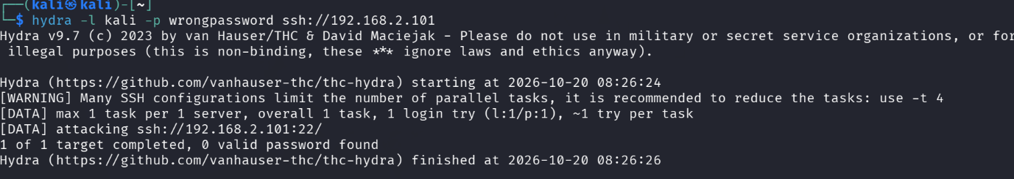
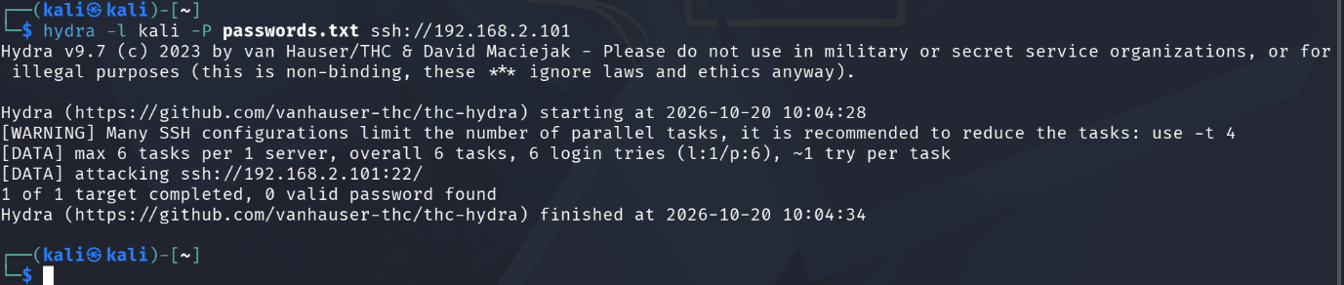

  - Wazuh Findings
Whereas the perimeter tools monitored traffic moving across the network, the Wazuh SIEM platform delivered detailed insight into activity occurring locally on the target operating system.
• Agent Integrity: The management console confirmed that agent ID 005, registered to the hostname SOC_3_BARCLAYS, was active and operating on Ubuntu 24.04.4 LTS while transmitting telemetry at regular intervals.
• Endpoint Security Alerts: After the automated password-guessing tool was launched from Kali, the Ubuntu system log recorded a sharp increase in failed authentication attempts, which Wazuh promptly categorised as critical operational alerts.
• Telemetry Details: These alerts received high-severity threat classifications and clearly identified the source IP address (192.168.1.101), the targeted usernames (trial, telnetuser), and the associated rule severity levels.
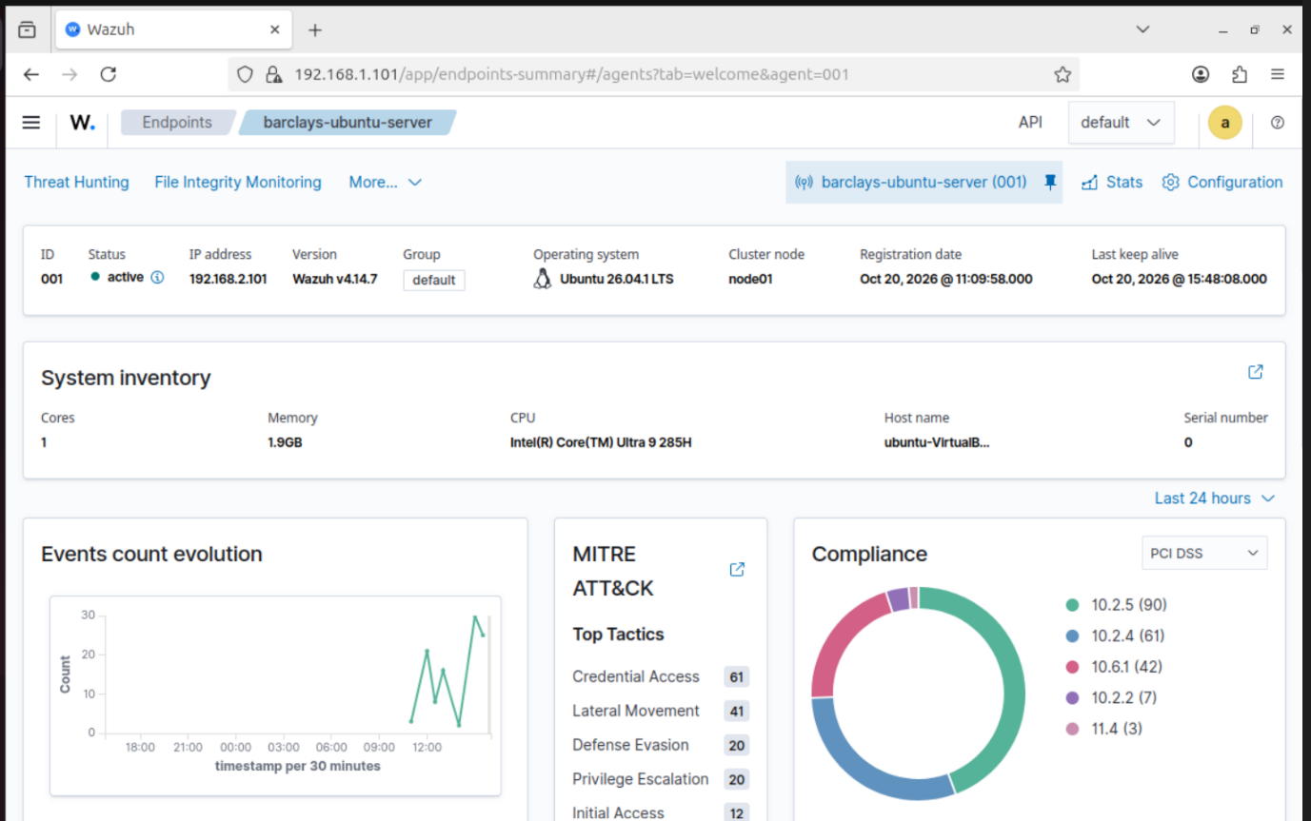
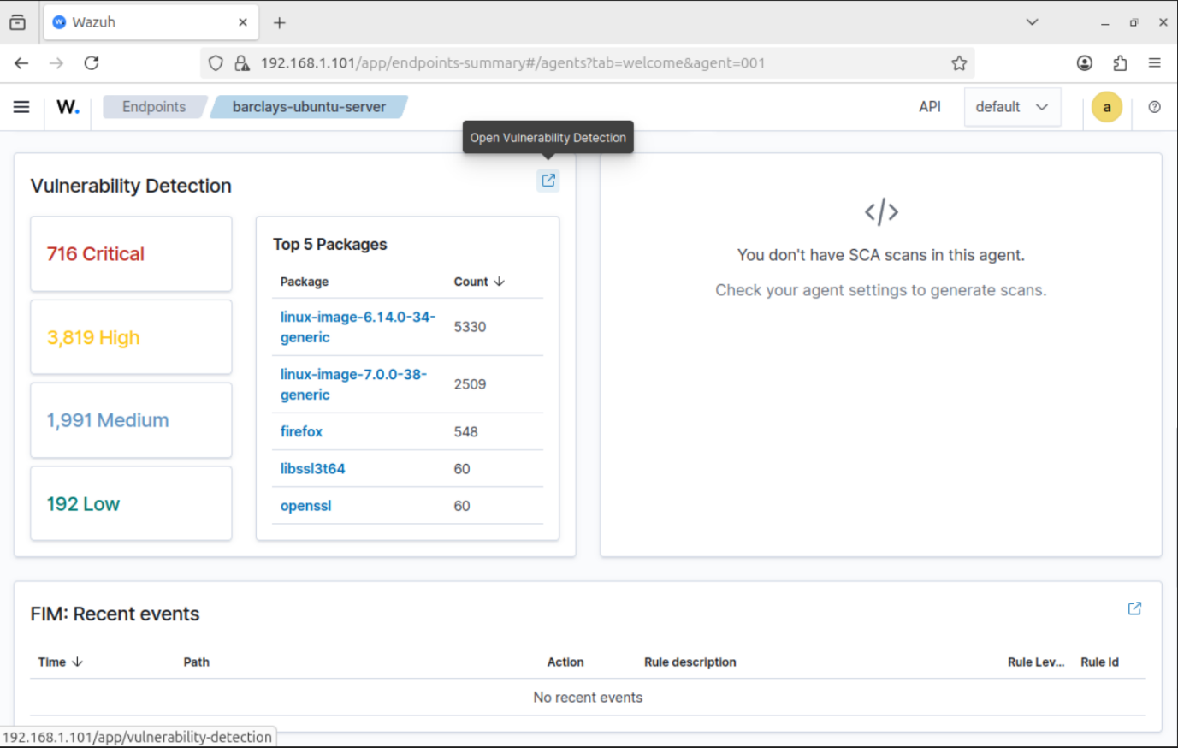
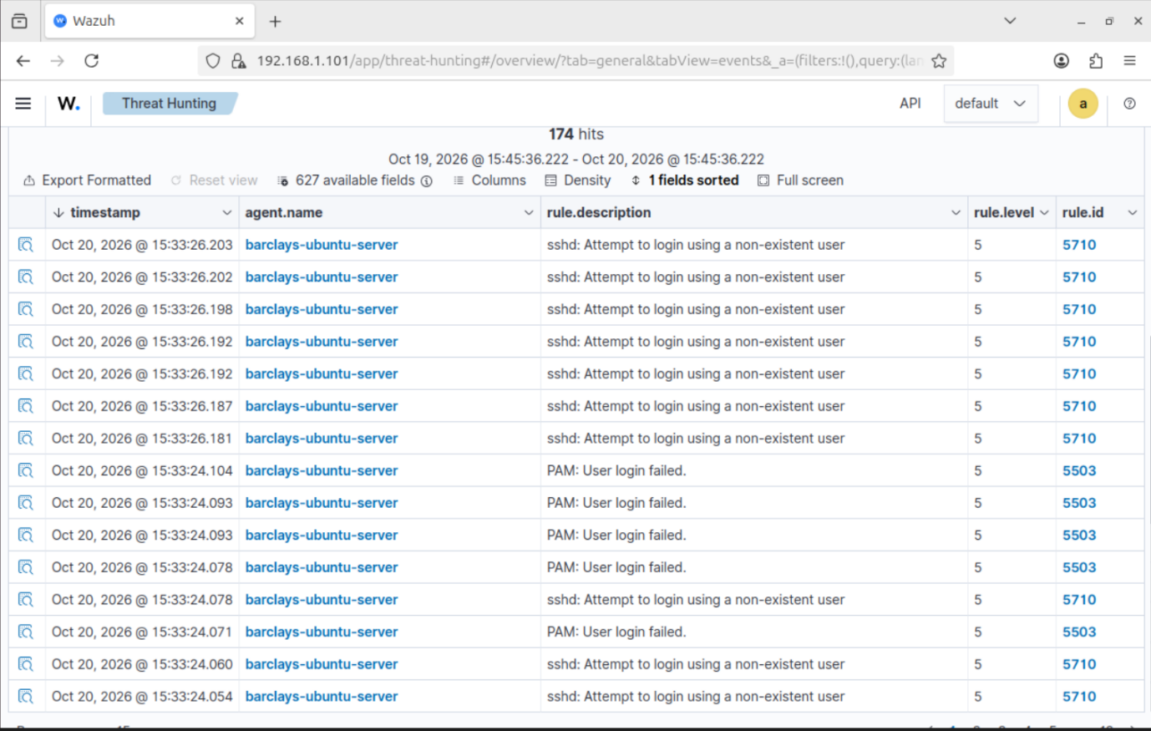
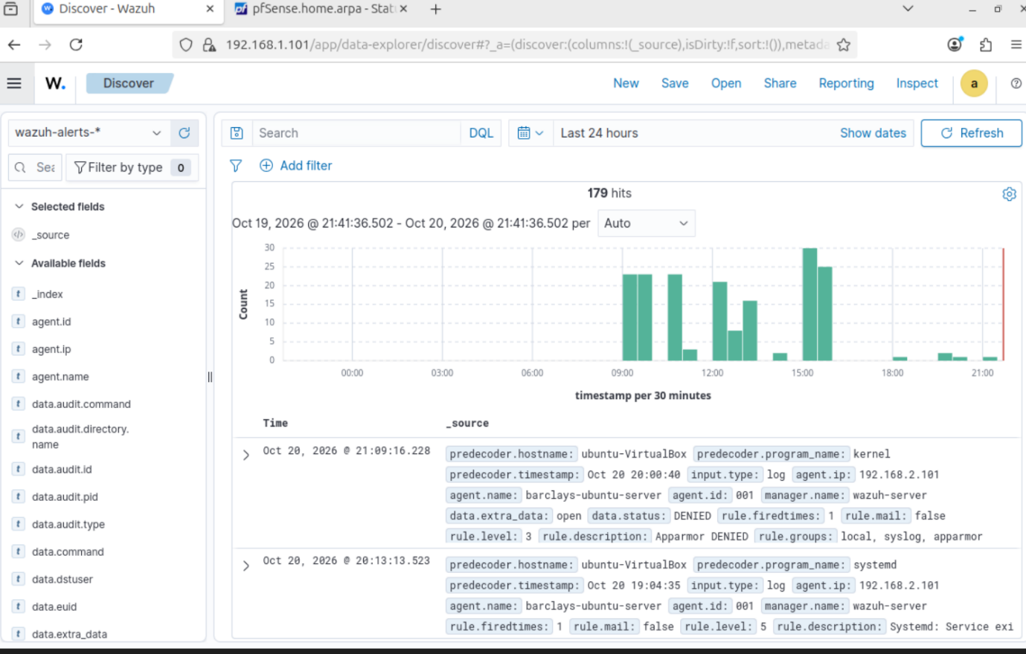

- Incident Assessment
The audited technical components and evidence parameters are organized in the analytical assessment frame below:
Assessment Area | Evidence
Source IP | 192.168.1.101 (External Kali Machine located on WAN segment)
Target System | 192.168.2.101/SOC_3_BARCLAYS (Internal Ubuntu Production Server
Suspicious Activity | Sequential ICMP network ping sweep, Nmap, port scanning, and automated SSH brute-force actions.
Firewall Evidence | Perimeter logging showing initial access allowed, followed by explicit drop confirmation post-remediation.
Endpoint Evidence | Wazuh authentication event tracking parsing dense SSH failure packets from user accounts (trial/telnet user)
Final Assessment | Malicious

Critical Analytical Justification
The observed activity should be classified as malicious rather than benign or merely suspicious. The sequence aligns with a recognised cyberattack lifecycle: the external actor first conducted infrastructure discovery through an ICMP ping sweep, progressed to targeted reconnaissance using Nmap to identify exposed services, and then initiated an active compromise attempt through an automated Hydra brute-force attack against SSH. The frequency, volume, and systematic nature of the authentication attempts strongly indicate deliberate automation rather than accidental login failures. When correlated across Wireshark packet captures, pfSense firewall logs, and Wazuh endpoint alerts, the evidence demonstrates a coordinated attempt to gain unauthorised access to the Ubuntu server.

- Recommendations
To protect Barclays Telco's infrastructure from future password-guessing and reconnaissance attacks, the following defensive improvements should be implemented immediately:
• Implement Host-Based Intrusion Prevention (Fail2ban): Deploy fail2ban on all production Ubuntu endpoints. This ensures that any source IP generating excessive failed login attempts within a set window is automatically blocked via local firewall chains.
• Enforce Key-Based SSH Authentication & Modify Default Ports: Disable password authentication entirely inside the SSH configuration, forcing the use of secure cryptographic SSH keys. Additionally, move the public SSH service off standard TCP port 22 to a non-standard high port to break automated discovery scans.
• Deploy Network Access Control Lists (NALs) & Least Privilege Rules: Update perimeter firewall configurations to block direct management access from external WAN addresses, requiring a secure VPN or jump box session instead.

- Conclusion
This project strengthened my understanding of how network- and host-level security tools work together within a defence-in-depth architecture. Wireshark provided detailed visibility into scan traffic, Wazuh confirmed authentication failures on the endpoint, and pfSense enforced the controls needed to stop the attack. It also demonstrated that SOC analysts must identify and contain threats quickly to prevent data loss and the resulting financial impact.

- References
- Canonical (n.d.) OpenSSH server. Ubuntu Server documentation. Available at: https://ubuntu.com/server/docs/how-to/security/openssh-server/ (Accessed: 20 October 2026). Ubuntu Server documentation
- MITRE (n.d.a) Brute Force: T1110. MITRE ATT&CK. Available at: https://attack.mitre.org/techniques/T1110/ (Accessed: 20 October 2026). MITRE ATT&CK®
- MITRE (n.d.b) Network Service Discovery: T1046. MITRE ATT&CK. Available at: https://attack.mitre.org/techniques/T1046/ (Accessed: 20 October 2026). MITRE ATT&CK®
- National Institute of Standards and Technology (NIST) (2025) Incident Response Recommendations and Considerations for Cybersecurity Risk Management: A CSF 2.0 Community Profile. NIST Special Publication 800-61, Revision 3. Available at: https://doi.org/10.6028/NIST.SP.800-61r3 (Accessed: 20 October 2026). CSRC
- Netgate (n.d.) Rule methodology. pfSense documentation. Available at: https://docs.netgate.com/pfsense/en/latest/firewall/rule-methodology.html (Accessed: 20 October 2026). pfSense Documentation
- Nmap Project (n.d.) Nmap reference guide. Available at: https://nmap.org/book/man.html (Accessed: 20 October 2026). Nmap Network Scanning
- Sharpe, R., Warnicke, E. and Lamping, U. (n.d.) Wireshark user’s guide. Available at: https://www.wireshark.org/docs/wsug_html_chunked/ (Accessed: 20 October 2026). wireshark.org
- The Hacker’s Choice (n.d.) THC Hydra. GitHub repository. Available at: https://github.com/vanhauser-thc/thc-hydra (Accessed: 20 October 2026). vanhauser-thc/thc-hydra: hydra · GitHub
- Wazuh (n.d.) Log data collection. Wazuh documentation. Available at: https://documentation.wazuh.com/current/user-manual/capabilities/log-data-collection/index.html (Accessed: 20 October 2026).

